**Payroll Accounting**

Payroll accounting is a system that records and keeps track of payroll related expenses. It doesn’t include rent, utilities, equipment or any other business expenses unrelated to employee benefits. Payroll accounting doesn’t keep track of business taxes such as sales or any income taxes. The information input into a payroll accounting system is stored in a payroll journal entries. These provide records of payroll expenses and details about each transaction and a general ledger will record each journal entry for financial reporting and business related purposes.

Expenses that may fall under payroll accounting can be employee compensation which includes the employee’s gross salary or wages, paid time off, bonuses, commissions, and other taxable income. Also taxes and insurance expenses which include any payroll taxes withheld from paycheques, including federal income taxes and social security, medicare, applicable state or local income taxes , and worker’s compensation. Another expense that may fall under payroll accounting is employee benefit payment and includes health insurance premiums, and any supplemental insurance. Moreover, employer taxes which includes portions of medicare and social security payments for employees. Lastly, other benefits which may include tuition reimbursement or other fringe benefits , as well as wage garnishment or additional tax liabilities may fall under payroll accounting.

For payroll accounts, you can choose between 3 types of journal entries to help ensure payroll is correctly recorded in the system. First the original entry, which is the standard method to enter payroll data. These entries include your employees’ gross earnings, taxes and withholdings. Second, accrued wages which is used at the end of an accounting period. It will also include wages that you still owe your employees. Once these wages are paid, you make reversed entries in your ledger to account for this payment. Last, manual payment which can be used to adjust an employee’s pay.

Payroll accounting starts with setting up a system that works for your business. You must consider automating payments processes using a third party payroll provider that intergrates with payroll to help save time and resources. You must then create accounts for each expense type. You can then set up the payroll accounting software to automate issuing regular employee payments. Even if you automate processes it is still a good idea to routinely check payments for accuracy. Afterwards, you can create a detailed accounting reports by compiling payment records for a single pay run or over a certain period. You can then start, stop or change payments amount as employees leave or join the business, as compensation changes, or if tax rates change.

Requirement Gathering Techniques for Pay-roll Accounting System:

i)  Interviews:  
Sample Interview Questions:

1. Can you describe the current payroll process in detail?
   * Objective:  Understand the existing payroll procedures, systems, and potential pain points.
2. What are the primary challenges or limitations faced in the current payroll system?
   * Objective:  Identify areas of improvement and critical issues that need to be addressed in the new system.
3. What features or functionalities would you like to see in the new payroll accounting system?
   * Objective:  Gather specific requirements and preferences from stakeholders to ensure the new system meets user needs.
4. How do you envision the integration of the new payroll system with other existing systems within the organization?
   * Objective:  Understand the integration requirements and potential dependencies with other systems.
5. Who are the key stakeholders involved in the payroll process, and what role do they play?
   * Objective:  Identify stakeholders who should be involved in the requirements gathering process and ensure that all perspectives are considered.

Who will be interviewed:  HR personnel, finance professionals, IT experts, payroll administrators, and key stakeholders involved in the payroll accounting system.

ii)  Questionnaire:  
Sample Questionnaire:

1. Rate the effectiveness of the current payroll system in meeting your needs. (On a scale of 1 to 5)
   * Objective:  Collect quantitative data on user satisfaction with the existing system.
2. What are the top three features you consider essential in a payroll accounting system?
   * Objective:  Prioritize key features based on user preferences and requirements.
3. How often do you encounter errors or discrepancies in the current payroll calculations?
   * Objective:  Identify common issues and areas for improvement in accuracy.
4. Do you find the current reporting capabilities of the payroll system sufficient for your needs?
   * Objective:  Gather feedback on reporting requirements and potential enhancements needed.
5. Would you prefer a cloud-based or on-premise payroll system? Why?
   * Objective:  Understand user preferences regarding the deployment model for the new system.

Who will be questioned:  Employees involved in the payroll process, managers overseeing payroll operations, and other relevant stakeholders within the organization.

The planning phase is the essential step in figuring out why an information system should be constructed and how the project team will approach its development. The planning phase of systems analysis and design establishes the framework for the entire process. It comprises defining the project's objectives, constraints, and scope as well as identifying the stakeholders and their needs. Feasibility studies are conducted to assess the project's technical, financial, operational, and scheduling viability. A project plan lays out the tasks, due dates, supplies, and risk management strategies. This step also includes developing a project budget and securing the necessary funding and clearances. Effective planning not only lowers risks and increases the possibility of successful completion, but it also ensures that the project is in line with corporative objectives. Dennis et al. (2015).

The financial operations of a company can be greatly enhanced and streamlined with the help of an accounting payroll system. Payroll process automation ensures fast and accurate payment disbursement, minimizes computation time, and removes manual errors. By reducing the possibility of penalties, this system also helps to preserve compliance with tax rules and regulations. It also offers insightful information about labor expenditures, which facilitates improved decision-making and budgeting. It improves the organization's overall efficiency and transparency by centralizing employee data and producing thorough reports.

Numerous sides of a company's operations can be greatly improved and streamlined by an accounting payroll system. Businesses can save time, increase productivity, and decrease manual errors by automating payroll procedures. Better financial planning and decision-making are also made possible by these systems' real-time labor cost data. Additionally, they guarantee adherence to intricate tax laws and regulations, hence reducing the possibility of penalties and fines. Furthermore, to provide a smooth and effective process, accounting payroll systems frequently link with other business software, including HR and accounting systems. In the end, these solutions provide improved operational excellence, cost reduction, and productivity.

Payroll systems simplify a number of corporate functions. By automating computations, they guarantee quick and precise processing of taxes, deductions, and employee salaries. HR staff may now concentrate on strategic projects since this frees up their time. Payroll systems also ensure adherence to complex labor laws and regulations, lowering the possibility of expensive fines. Additionally, they support financial planning and decision-making by offering insightful information in comprehensive reports. Payroll systems enhance overall company success by increasing productivity, accuracy, and compliance.

Numerous parties are involved in an accounting payroll system, and each has certain duties and interests. Because payroll has a direct impact on their salary, employees are the main stakeholders. They want their salaries and benefits to be paid accurately and on time. Management is in charge of making that payroll is processed accurately, effectively, and in accordance with all applicable rules and regulations. In addition to managing financial reporting and tax-related issues, the HR department frequently supervises payroll administration. Government organizations are external parties that must adhere to labor and tax regulations, which include timely tax payments and proper payroll reporting. Payroll service providers, if they are outsourced, are important parties in charge of processing payrolls accurately and on schedule. If available, unions represent the interests of workers and may participate in payroll-related collective bargaining agreements. The teams in charge of accounting and finance are essential because they keep track of payroll transactions, provide financial reports, and make sure that accounting rules are followed. Lastly, IT staff members could be involved in payroll system implementation, upkeep, and troubleshooting.

Many stakeholders in a business can benefit greatly from an accounting payroll system. It minimizes mistakes and annoyances for workers by guaranteeing precise and prompt salary computations and disbursements. It offers a consolidated platform for handling perks like leaves and personal data. It simplifies payroll procedures for firms by automating computations, producing reports, and guaranteeing adherence to tax laws. This lessens the possibility of fines and the administrative load. Providing real-time insights into payroll trends and expenditures facilitates improved financial planning and decision-making. Its smooth integration with accounting software allows accountants to save time and effort by automating data entry and reconciliation. Additionally, by providing real-time insights into payroll trends and expenditures, it facilitates improved financial planning and decision-making. Its smooth integration with accounting software allows accountants to save time and effort by automating data entry and reconciliation. Also, it offers useful financial information for evaluation and choices. All parties involved in the payroll process gain when efficiency, accuracy, and compliance are improved by an accounting payroll system.

An accounting payroll system may be impacted by a complex and multidimensional setting. It covers a broad range of elements, including as organizational structure, workforce demographics, economic situations, technological developments, and legal and regulatory needs. Payroll computations and compliance may be greatly impacted by changes in laws and regulations, including those pertaining to taxes, minimum wages, and labor standards. Wage adjustments and benefit packages may be impacted by economic factors like as unemployment and inflation rates. Automation tools and cloud-based payroll systems are examples of technological innovations that can increase productivity and streamline procedures. The complexity of payroll administration can be influenced by organizational structure, including the number of divisions, locations, and personnel. Additionally, because of differing tax rates and eligibility for benefits, employee attributes like age, gender, and geography may have an impact on payroll computations. Payroll systems must adjust to the dynamic context created by the interactions and influences of all these variables in order to continue being accurate, compliant, and effective.

There are a number of presumptions involved in creating an accounting payroll system. Its main presumption is that all data including employee details, hours worked, pay rates, tax rates, and deductions will be entered consistently and accurately. It also presumes adherence to pertinent tax laws and rules, which can differ from one jurisdiction to another and evolve over time. Additionally, the system makes the assumption that all workers receive their paychecks on time and that no unanticipated events like unplanned leaves of absence or changes in job status occur that might necessitate revisions. It also presumes that the hardware and software of the system will work dependably and that sufficient resources will be available for updates and maintenance. Lastly, it makes the assumption that users of the system will possess the skills and information required to use it efficiently.

**References**

Dennis, A., Wixom, B. H., & Roth, R. M. (2015). *Systems Analysis and Design, 5th Edition Wiley E-Text Student Package*.

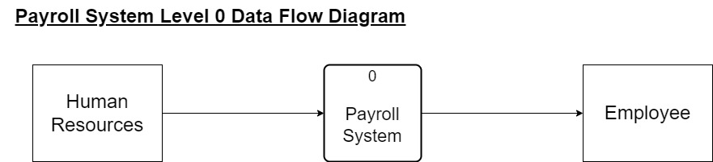

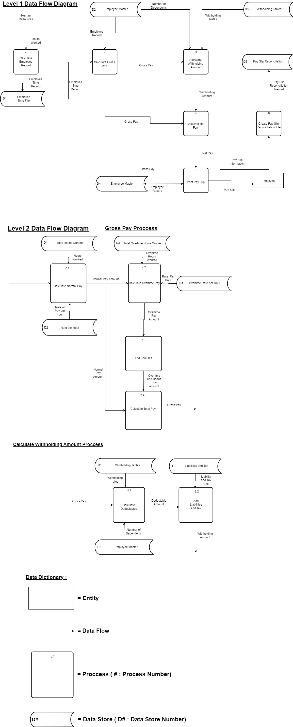

GitHub Accounts

1. [Thobiswa03](https://github.com/Thobiswa03)